Functional Requirements:

1. Users shall log into an account to access the system.
   1. The system shall display a login screen requesting a username and password, which includes a login button and a button to create an account (See R2).
   2. The user shall enter a username and password and press a login button.

* 1. The system shall check if the user supplied correct login information.
     1. The system shall query the login database for a record with a “username” value equal to the username submitted by the user.
        1. If the query does not return a record, i.e., the username does not exist in the database, the system shall show an error message and return to Step 1.1.

* + - 1. If the query does return a record, i.e., the username exists in the database, the system shall continue to Step 1.3.2.
    1. The system shall check for equivalence with the supplied password using the query made in Step 1.3.1.
       1. If the supplied and retrieved password information do not match, the system shall show an error message and return to Step 1.1.

* + - 1. If the supplied and retrieved password information match, the system shall continue to Step 1.4.
  1. The system shall check if the record found in Step 1.3.1 corresponds to a regular “user” account or to a “manager” account with heightened privileges.
     1. If the record is of type “user”, the system shall display a main menu to the user.

* + 1. If the record is of type “manager”, the system shall display a main menu to the user with the option to schedule group meetings (As defined in R8).

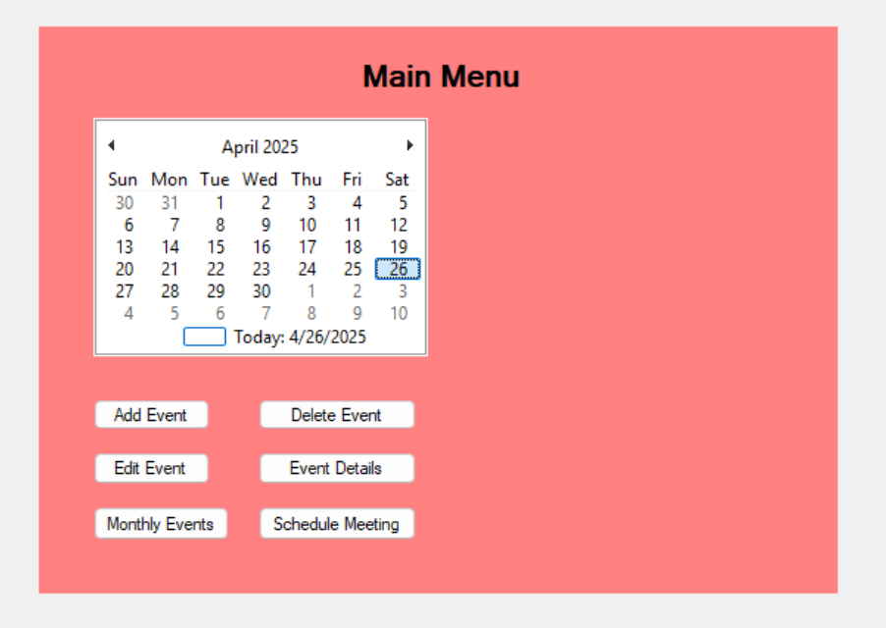

1. Users shall be able to create an account to access the system.
   1. The user shall click the “Create Account” button.
   2. The system shall request a username and password from the user.
      1. The system shall display three textboxes: “Username”, “Password”, and “Confirm Password”.

* 1. The user shall enter a username, password, and password confirmation.
  2. The system shall check if the password is equal to the password confirmation.
     1. If the entered password is not equal to the entered password confirmation, show an error and return to Step 2.3.

* + 1. If the entered password is equal to the entered password confirmation, continue to Step 2.5.
  1. The system shall add the username and password to the login information database.
  2. The system shall inform the user of successful account creation and return to the login screen.

1. The system shall allow the user to add an event to the calendar, while also performing conflict checks with existing events.
   1. The system shall display the main menu, which includes the monthly-based event list (see R6).

* 1. The user shall click the “Add Event” button.
  2. The system shall request the user to enter event information into an “Add Event” form.

* 1. The user shall enter all required event information into the form (See NR1).
  2. The system shall check if this event overlaps with any other events in the calendar.
     1. The system shall obtain all events from the event database that occur on the same day as the new event.
     2. For each retrieved event, the system shall determine if it overlaps with the new event.
        1. If either event’s start time occurs between the start and end time of the other event, the system shall display an error and return to Step 3.3

* + - 1. If no overlap is found, and there are more events in the list of events retrieved from the database, check the next retrieved event for overlaps.
      2. If no overlap occurred, and there are no more events in the list of events retrieved from the database, the system shall continue to Step 3.6.
  1. The system shall add this event to the events database.
  2. The system shall inform the user that the event has been added to the database successfully and prompt the user to either add another event or return to the main menu.

* + 1. If the user elects to add event, the system shall return to Step 3.3.

* + 1. If the user elects to return to the main menu, the system shall return to the main menu.

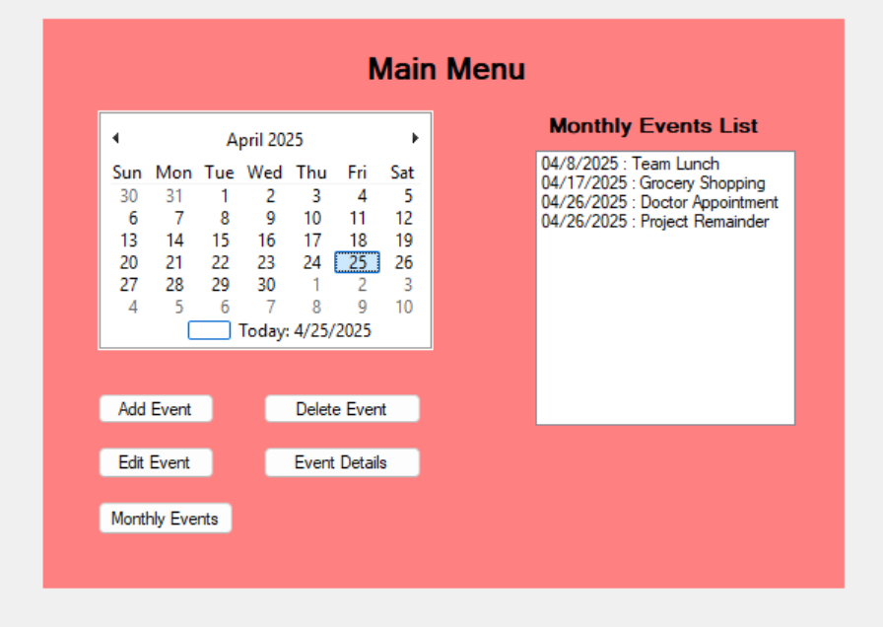

1. The system shall allow users to delete personal events and allow only managers to delete group events from the monthly-based event list.
   1. The user shall select a date from the calendar.

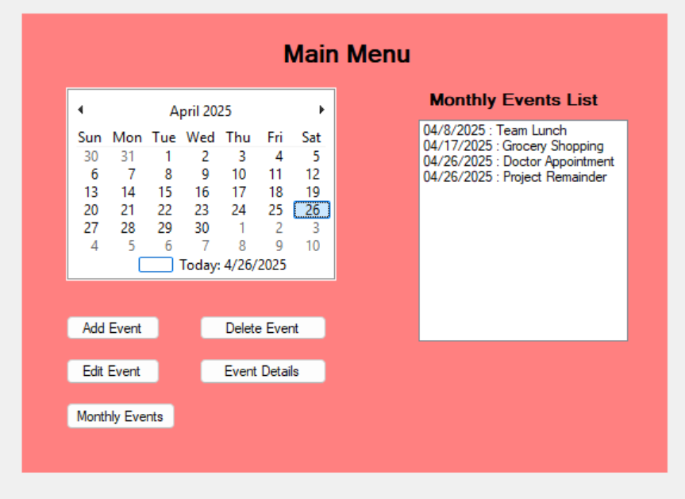

* 1. The system shall display events associated with the selected date.
  2. The user shall click on an event they want to delete.
  3. The system shall check whether the selected event is a personal event or a group event.
     1. If the selected event is a personal event created by the user/manager:
        1. The system shall display a “Delete Event” button.

* + - 1. The user shall click the “Delete Event” button.
      2. The system shall display a confirmation prompt.

* + - 1. If the user confirms, the system shall delete the event from the database.
      2. The system shall display a success message and return to the main menu.



* + 1. If the selected event is a group event :
       1. If the user is the manager, the system shall display a “Delete Event” button.

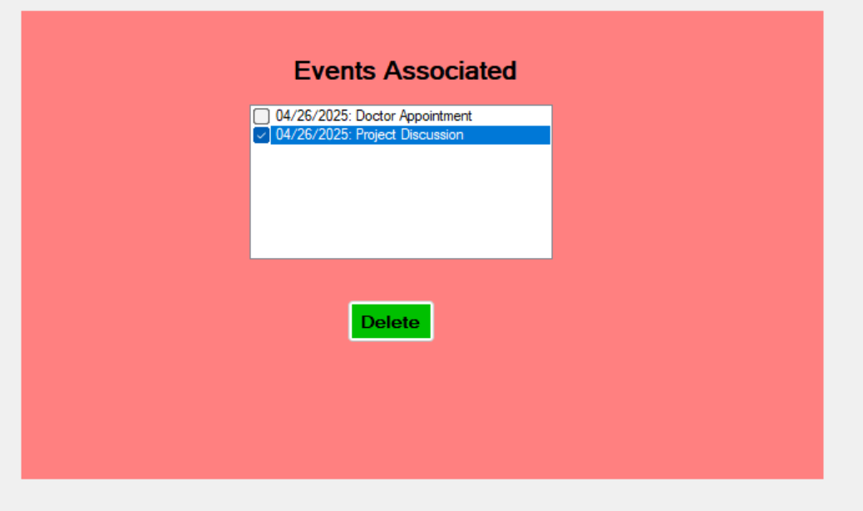

* + - 1. Upon clicking the button and confirming, the event shall be deleted from all participants’ calendars.
      2. The system shall display a success message and return to the main menu.

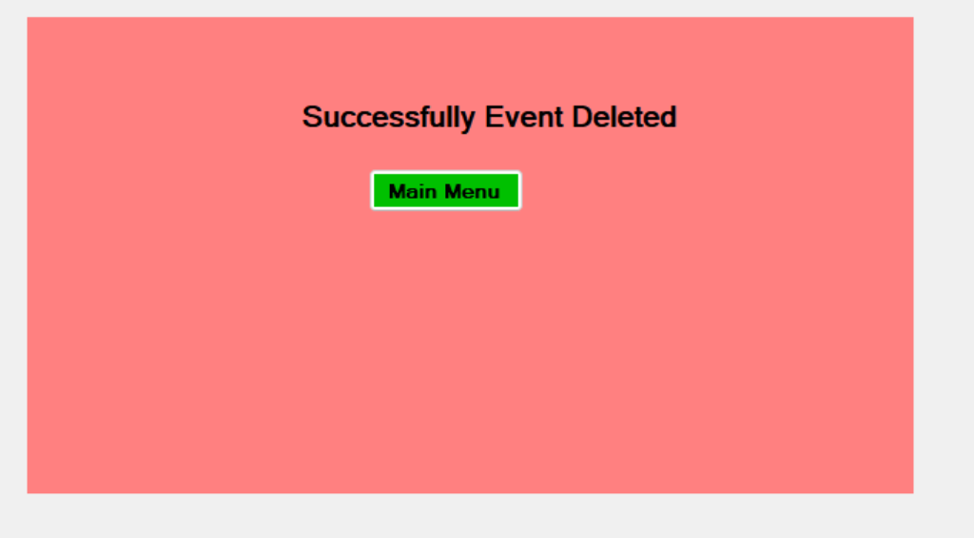

* + - 1. If the user is not the manager, the system shall block the action and display an error message.

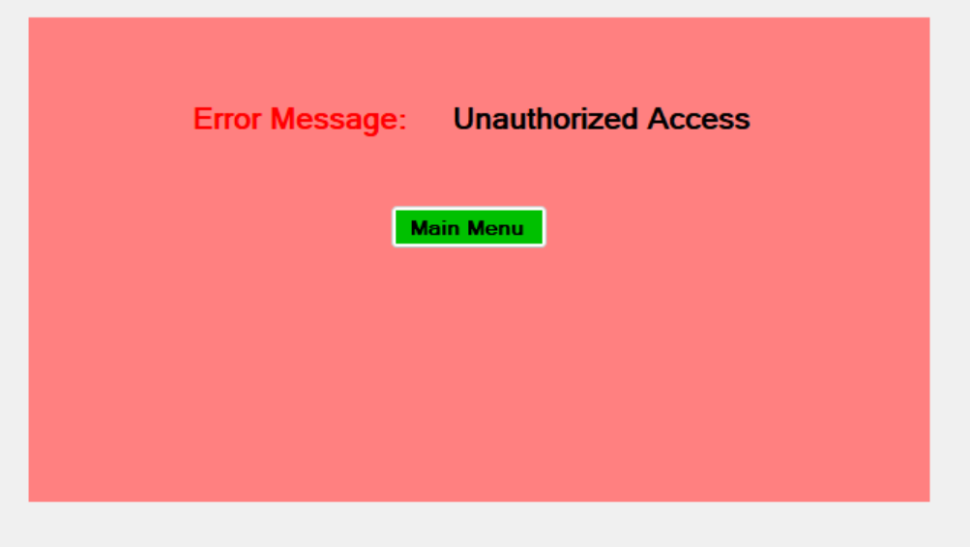

1. The system shall allow users to edit personal events and allow only managers to edit group events, with changes reflected in all attendees' calendars.
   1. The user shall select a date from the calendar.



* 1. The system shall display events associated with the selected date.

* 1. The user shall click on an event they want to edit.
  2. The system shall check whether the selected event is a personal event or a group event.
     1. If the selected event is a personal event created by the user/manager.
        1. The system shall display an “Edit Event” form with current event details pre-filled.

* + - 1. The user shall modify the fields like title, date, time, and length.
      2. The system shall validate the updated inputs and save the changes to the database.
      3. The system shall display a success message and return to the main menu.

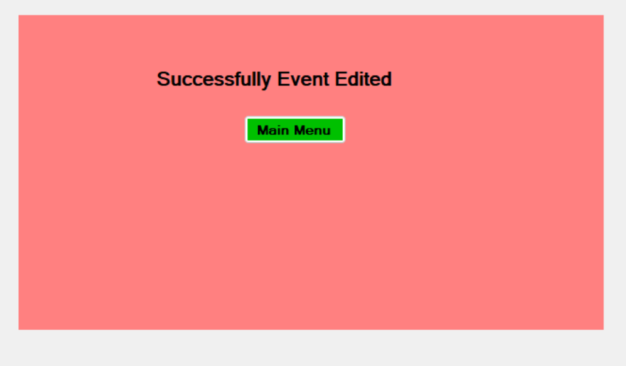

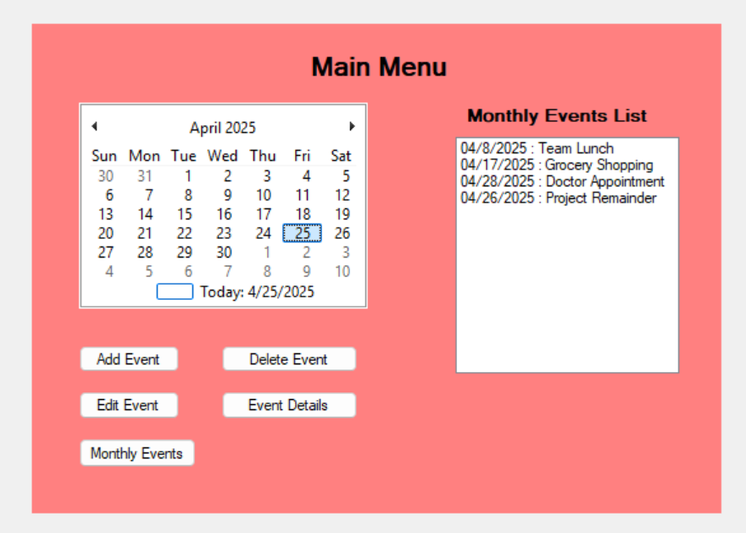

* + 1. If the selected event is a group event:
       1. If the user is the manager, the system shall allow modifications and update all participants’ calendars accordingly.
       2. The system shall display a success message and return to the main menu.

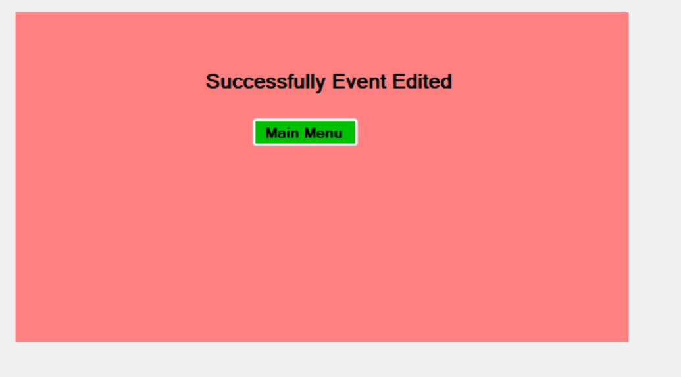

* + - 1. If the user is not the manager, the system shall block the edit attempt and display an error message.



1. The system shall allow a user to view the details of an event on the monthly-based event list.
   1. The system shall display the main menu, which includes the monthly-based event list described in R7.



* 1. The user shall click on an event in the monthly-based event list.
  2. The system shall retrieve event information from the event database based on the event id.
  3. The system shall display the event information as retrieved from the event database to the user in a pop-up window.

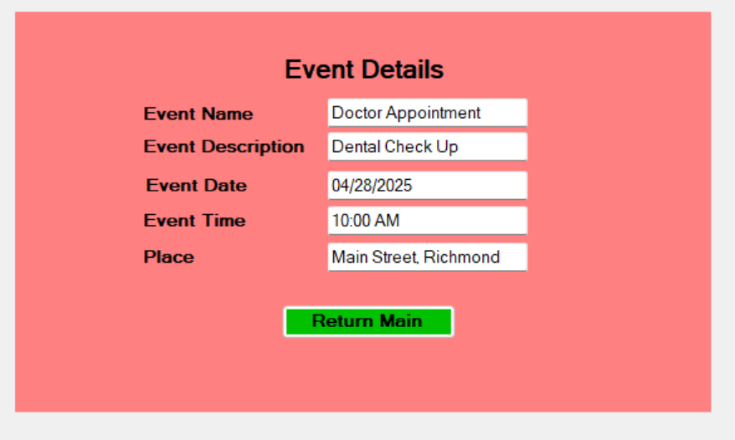

* 1. The user shall click the “Return to Main Menu” button when they are done viewing the event.
  2. The system shall return to the main menu.

1. The system shall allow the user to view a monthly-based event list.
   1. The system shall display the main menu.

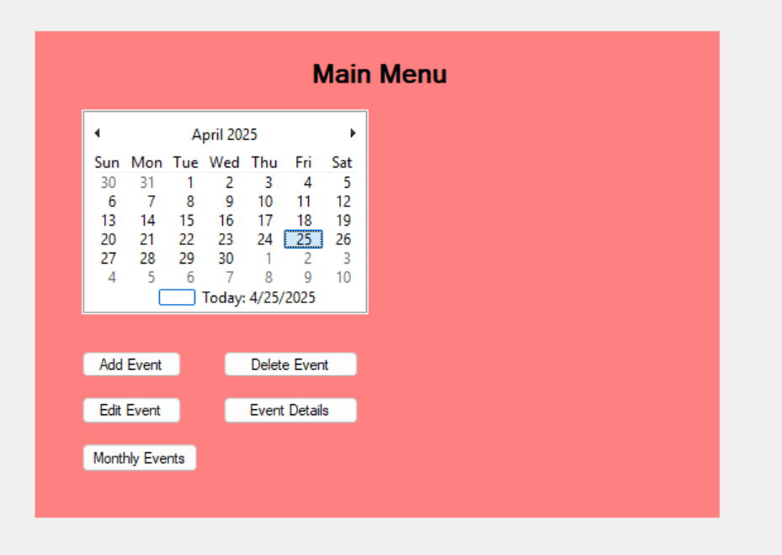

* 1. The system shall generate a monthly-based list of user events.
     1. From the event database, the system shall retrieve all events where the event’s month corresponds to the current month, and either the user created the event (for personal events), or the user has been invited to the event (for group events).
     2. The system shall populate the monthly-based event list textbox with the retrieved events.



1. The system shall allow the manager to schedule a meeting.
   1. The system shall display the main menu.

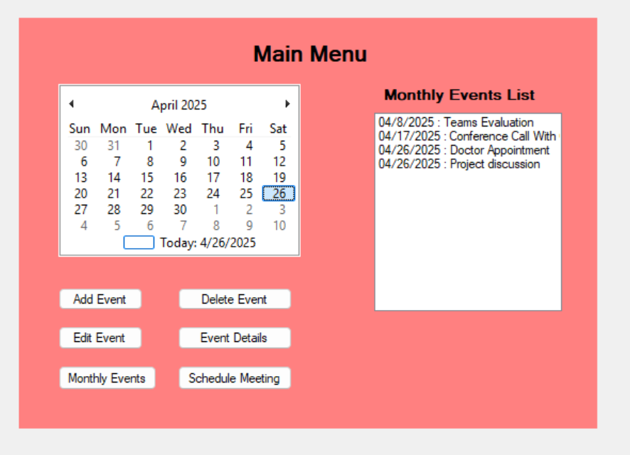

* 1. The manager shall select a schedule meeting option on the calendar.
  2. The manager shall select a date and the team members to attend the meeting.

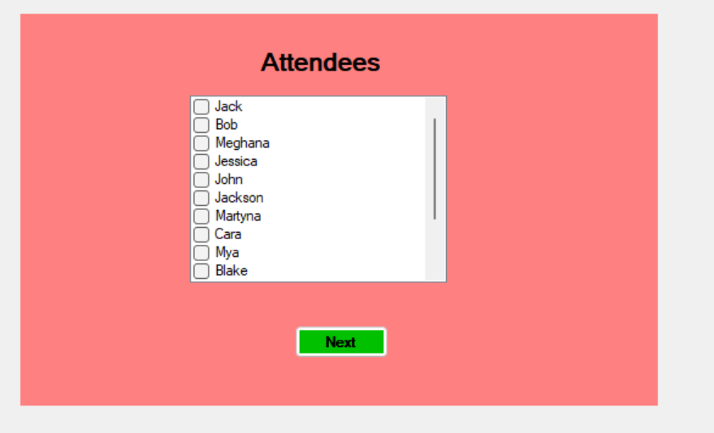

* 1. The system shall check the availability of all the selected members on the specified date.
     1. The system shall retrieve the scheduled events for each member from the database for the chosen day.
     2. The system shall check if all members are available at the event start time, lasting for the length of the event.
        1. If the system finds schedule conflicts...
           1. The system shall find the nearest available date for all members to attend by repeating Step 8.4.1 for each successive day.

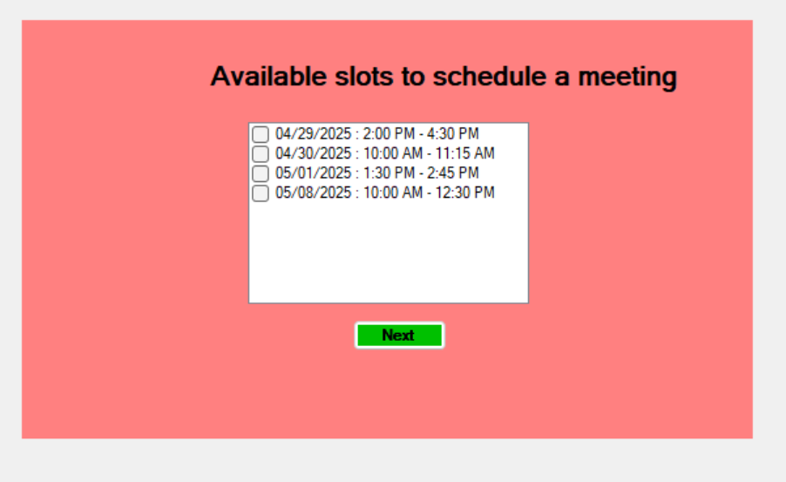

* + - * 1. The system shall also display the members available for the day selected by the manager.

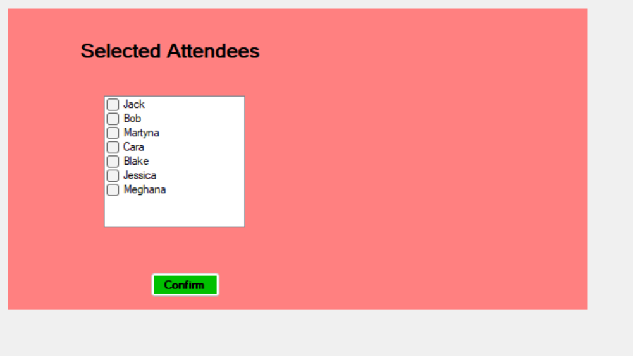

* 1. The system shall display the nearest available date that all members can attend, as well as the selected members that can attend the selected date.

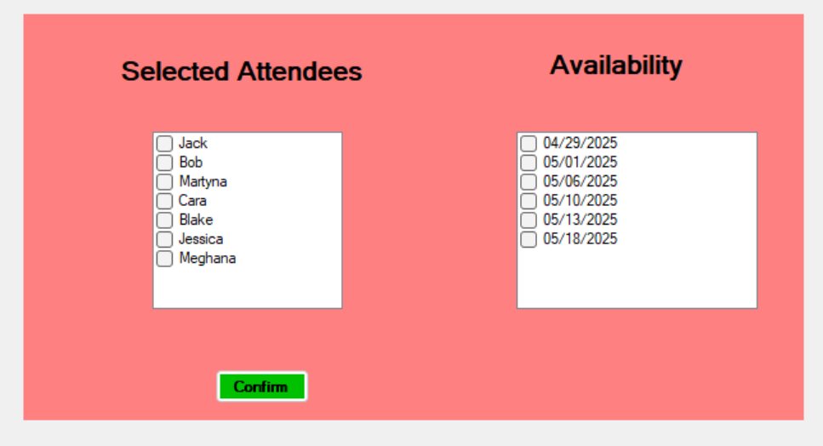

* 1. The manager shall confirm if the date they selected (where not all members can attend) is sufficient or select the option for the next available date.
  2. The system shall return to Step 8.1.



Non-functional Requirements:

1. Events shall contain the following information: event date, event time, event length, and event name, and event description.
2. The main menu shall contain both a calendar and a monthly-based event list.
3. Updates to group events shall be instantly reflected in all attendees’ calendars.
4. User accounts shall be of one of two types: “User” and “Manager”, where the latter has the added privilege of managing group meetings.
5. The system shall enforce access control to prevent unauthorized users from editing or deleting group events, showing alert messages in the event of attempted unauthorized event changes.
6. Any password textbox must use asterisks to hide entered characters from view.
7. The system shall display monthly view of events within 1 second.
8. The system shall check for conflicts and availability for meetings within 3 seconds.